CLASSIFICATION ASSIGNMENT
Database: Chronic Kidney Disease
Problem Statement
Stage1:Machine Learning
Stage2:Supervised Learning[ Input & output is clear]
Stage3:Classification[Output is categorical value]
Information About Database
No of Rows:399
No of Columns:28
Preprocessing Method
Converting String to Number :One Hot Encoding Algorithm
[ In our database we are converting bg,rbc,pc,pcc,ba,htn,dm,cad,appet pe, & ane columns into number ]
Model Creation
1.Decision Tree:
Confusion Matrix
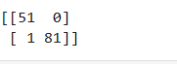

Classification Report
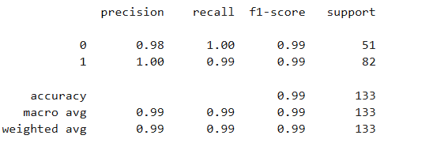
Best Parameter (f1_score)
Roc_Auc_Score
0.9939024390243902

2.Logistic Regression:
Confusion Matrix
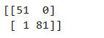

Classification Report
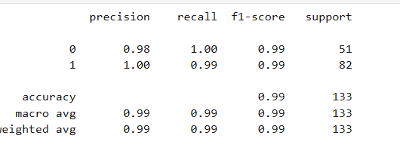

Best Parameter (f1_score)
Roc_Auc_Score
1.0

3.Random Forest:
Confusion Matrix
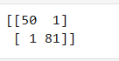
Classification Report
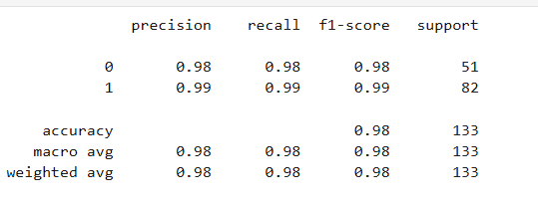
Best Parameter f1_score)
Roc_Auc_Score
0.9997608799617408
4.Support Vector Machine:
Confusion Matrix
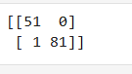

Classification Report
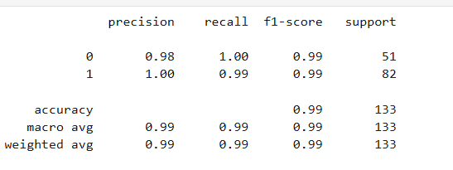

Best Parameter f1_score)
Roc_Auc_Score
1.0

Best model of CKD database is
- Logistic Regression
b) Support Vector Machine

Based on Classification Report & Roc_Auc_Score
I Choosed this model.

